# Best RSI Signal Based on Plot (Question 3/3)

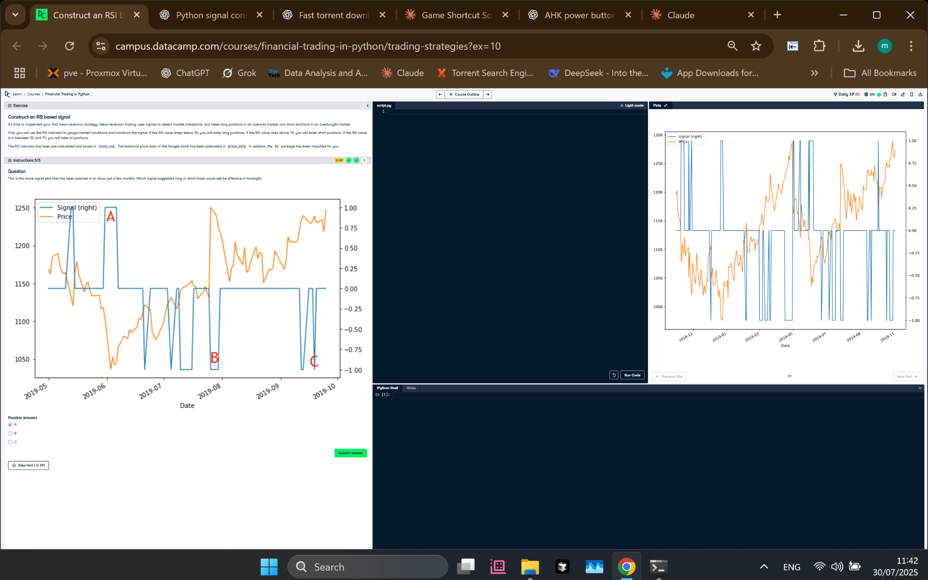

Figure: Signal vs Price Plot with Marked Points A, B, and C.

## Correct Answer

**Correct Choice:** C

## Explanation

Point C is the most effective trading signal based on RSI. After the buy signal (1) at C, the price increased consistently, making it a profitable decision. Point A triggered a buy signal right before a price drop, and Point B showed little price movement after the signal, making them less effective. Thus, C is best in hindsight.

## Simple Explanation

Signal C gave a buy alert just before the price rose a lot. Signal A failed — price fell. Signal B didn’t lead to much profit. That’s why C was the best signal in the plot.